



Computer Communications 29 (2006) 1065–1078

www.elsevier.com/locate/comcom

Grooming of non-uniform trafﬁc on unidirectional and bidirectional rings

Raza Ul-Mustafa¹, Ahmed E. Kamal*
Department of Electrical and Computer Engineering, Iowa State University, Ames, IA 50011-3060, USA
Received 29 May 2003; revised 29 June 2005; accepted 4 July 2005
Available online 3 August 2005

Abstract
Trafﬁc grooming in WDM networks is obtained by intelligently allocating the trafﬁc onto a given set of wavelengths. This paper presents
heuristics for grooming of non-uniform general trafﬁc demands onto a given set of wavelengths available on a unidirectional or bidirectional
ring. The objective is to minimize the number of higher layer equipment, like SONET Add/Drop Multiplexers (ADMs), or MPLS routers. We
map the unidirectional ring onto a linear topology and develop a generalized two-step approach to solve the grooming problem on the
mapped topology. In the ﬁrst step, we allocate the trafﬁc while minimizing the possible number of strings (each string being a collection of
non-overlapping trafﬁc streams) in a manner that yields the optimal number of strings in the linear topology case. We also prove the
optimality of this step in the number of the strings (wavelengths). In the second step we employ a grouping technique to efﬁciently combine g
strings onto a wavelength while minimizing the total number of the ADMs. We also address the problem of grooming the non-uniform trafﬁc
on a bidirectional ring by mapping it onto unidirectional rings, and applying the two-step approach. Moreover, in the case of bidirectional
rings we propose an approach to route the trafﬁc that reduces the total number of the required wavelengths and ADMs. The time complexity
of our technique is at least an order of n less than other proposed approaches, where n is the total number of nodes in the network. The efﬁcacy
of the proposed technique has been demonstrated through a large number of experiments.
q 2005 Elsevier B.V. All rights reserved.

Keywords: WDM networks; Trafﬁc grooming; ADMs; Linear topology; Unidirectional ring; Bidirectional ring; Non-uniform trafﬁc; Asymmetric trafﬁc;
NP-completeness

1. Introduction

During the last decade, Wavelength Division Multi-
plexing (WDM) networks have emerged as an attractive
architecture for backbone networks. WDM networks
provide high aggregate bandwidth, on the order of several
Terabits per second. Also, WDM networks eliminate the
electro-optic processing delays using wavelength routing
[1]. However, the cost-effectiveness of WDM networks
depends on the amount of the optical passthrough provided
by the network to the given trafﬁc. The amount of the optical
passthrough in turn depends on the trafﬁc pattern and on the
way the trafﬁc between different source and destination

* Corresponding author. Tel.: C1 515 294 3580; fax: C1 515 294 1152.
E-mail addresses: razaulm@microsoft.com (R. Ul-Mustafa), kamal@
iastate.edu (A.E. Kamal).
1 Present address: Microsoft Corporation, One Microsoft Way, Redmond,
WA 98052-6399, USA
0140-3664/$ - see front matter q 2005 Elsevier B.V. All rights reserved.
doi:10.1016/j.comcom.2005.07.002

pairs is groomed (multiplexed) on the available set of
wavelengths. Trafﬁc grooming is thus deﬁned as an
intelligent allocation of the trafﬁc demands, between
different network nodes, onto an available set of wave-
lengths in such a way that reduces the overall cost of the
network.
WDM routing networks support lightpaths, which is a
pure optical communication path between two nodes. In
order to optimize the cost of the network, one needs to take
into account the higher layer that will use these lightpaths
and its connectivity patterns. The Synchronous Optical
Networks (SONET) is currently being used as a higher layer
in WDM networks, and because of its wide deployment and
efﬁcient protection schemes will remain the most likely
option for some time.
In Fig. 1, a typical WDM network is shown with three
nodes. Each node is equipped with an Optical Add/Drop
Multiplexer (OADM), which can selectively add or drop
wavelengths at each node, thus providing an optical
passthrough to the rest of the wavelengths. Each of the
wavelengths dropped at a node is then processed by the
higher layers Add/Drop Multiplexers (ADMs), e.g. a

1066

R. Ul-Mustafa, A.E. Kamal / Computer Communications 29 (2006) 1065–1078

OADM Fiber Links

ADM

ADM

OADM

ADM

Lightpaths

OADM

ADM

ADM

ADMs for
ADMs for
ADMs for

Fig. 1. An example of an optical network with OADMs and ADMs.

SONET ADM, after conversion into the electronic form.
Thus, the equipment needed at each node corresponds to the
number of wavelengths dropped at each node. To reduce
this number, and consequently the cost of equipment, one
needs to reduce the number of wavelengths dropped at a
node. We can achieve this goal by grooming the trafﬁc in
such a way that all the trafﬁc to and from a node is carried on
the minimum number of wavelengths.
As an example, consider a ﬁve-node linear topology
network, shown in Fig. 2. Let each node be equipped with an
OADM. Each OADM is in turn connected to a number of
SONET ADMs (not shown in the ﬁgure). Having an OADM
on each node will help only drop those wavelengths that
carry the trafﬁc to, or from that speciﬁc node. A wavelength
can bypass a node if it carries no trafﬁc that is transmitted or
received by that node. This will result in the saving of a
SONET ADM. Hence, our objective is to minimize the total
number of the SONET ADMs used in the network to
support all of the trafﬁc by intelligently assigning trafﬁc to
the wavelengths. Let g denote the total number of basic units
of trafﬁc supported by each wavelength. For example, if a
wavelength supports an OC-12 connection, and the basic
unit of trafﬁc is an OC-3, then gZ4. For illustrative purpose,
we assume that gZ2 in Fig. 2. Trafﬁc demands or
connections are shown by the line segments between the
source and destination nodes. Also, black circles are used on

(a)

the edges of the segments to represent a SONET ADM that
is used at the corresponding node, and for a speciﬁc
wavelength. To minimize the total number of ADMs
required, out of many possibilities, we could have the
following two allocations of trafﬁc to wavelengths.

(a) l₁: 142, 344; l₂: 145; l₃: 244; l₄: 245;
(b) l₁: 142, 244; l₂: 145; l₃: 344; l₄: 245;

Assignments (a) and (b) are shown in Fig. 2(a) and (b),
respectively. For the ﬁrst assignment the total number of
required ADMs is 10, while for the second assignment the
total number of ADMs is 9. Note that in the second
assignment the trafﬁc between nodes 1 and 2, and between 2
and 4 are sharing the same ADM. This example shows that
by assigning the trafﬁc to appropriate wavelengths, one can
reduce the number of required ADMs. Also, given very high
cost of SONET ADMs, approximately $40,000 for a single
port version, even saving few ADMs translates into savings
of hundred thousands of dollars.

2. Related work

Trafﬁc grooming in WDM networks is comparatively a
new ﬁeld, and has recently started to receive attention.
Few survey papers have been published in this area [3–5].

(b)
1
2
3
4
5

Fig. 2. Two different trafﬁc assignments on a linear topology, for the same trafﬁc demands.

R. Ul-Mustafa, A.E. Kamal / Computer Communications 29 (2006) 1065–1078

1067

The general problem of trafﬁc grooming with arbitrary
trafﬁc has been proven to be NP-Complete in [2]. Most of
the work related to trafﬁc grooming in WDM networks has
an emphasis on reducing the number of required higher
layer components [4]. However, there are some notable
exceptions in which other factors, like the network
utilization, are optimized, e.g. [18,19]. Also, most of the
work focuses on the special cases of the trafﬁc and the
speciﬁc network topologies. Many researchers focused on
obtaining the upper and lower bounds on the number of the
ADMs required for the speciﬁc topologies and trafﬁc
patterns [2,6–9], while few researchers proposed problem-
speciﬁc heuristics [12,13]. In the grooming literature,
uniform trafﬁc is deﬁned as the same amount of trafﬁc
between all possible source-destination node pairs, while
non-uniform trafﬁc is deﬁned as the variable amount of
trafﬁc between different source-destination node pairs. For
trafﬁc grooming problem, when trafﬁc between different
node pairs is non-uniform, few studies exist [8,10,12,13].
Many of such studies consider only non-uniform symmetric
trafﬁc, i.e. trafﬁc from(to) a speciﬁc source to(from) a
speciﬁc destination is same.
In [2], the authors besides proving the NP-Completeness
of the problem, also provided algorithms to minimize the
number of the ADMs when the trafﬁc from all nodes is
destined to a single node and all trafﬁc rates are the same.
For the more general case of all-to-all uniform trafﬁc, they
obtained a lower bound on the number of the ADMs
required and provide a heuristic to closely approach that
bound. Finally, they also considered the use of a hub node,
where the trafﬁc can be switched between different
wavelengths, and obtain an optimal algorithm that mini-
mizes the number of the ADMs by efﬁciently multiplexing
and switching the trafﬁc at the hub. In [6], the authors
considered six different optical WDM ring architectures.
They, then provide bounds on the number of the
wavelengths, number of the ADMs and maximum hop
length for each of the ring architectures. They also
considered three different trafﬁc models, namely, Static,
Dynamic and Incremental, and calculated the bounds for
each of the proposed six WDM ring architecture considering
some speciﬁc trafﬁc model. In [7], the authors while
grooming the trafﬁc considered the characteristics of the
SONET UPSR and BLSR rings. They presented the lower
bound on the number of the ADMs in a WDM UPSR ring,
under the uniform trafﬁc assumptions. Also they considered
the single-hub UPSR WDM ring and obtained the bound on
the number of ADMs required in case of uniform trafﬁc.
Similarly, they obtain the bounds on the number of ADMs
required for BLSR/2 WDM rings under the uniform trafﬁc
assumption. In [8], the authors concentrated on the Single-
Hub SONET/WDM ring architecture and obtained bounds
on the number of the ADMs required under both uniform
and non-uniform trafﬁc. They reduce the single hub trafﬁc
grooming problem to the bin-packing problem, and hence
used the approximation algorithms for bin-packing to solve

the non-uniform trafﬁc case in a near-optimal way. In [9],
the authors also focused on the WDM rings and obtained the
lower and the upper bounds by decomposing the ring into
sets of nodes and adopting the locally optimal topology
within each set. The optimal solutions obtained from sets of
nodes are then combined to get a near-optimal solution for
the whole ring. In [10], the authors consider the trafﬁc
scenario in which trafﬁc streams can exist between any
arbitrary pair of nodes. However, the demands between
same node pairs are considered to be symmetric. In [12], the
authors proposed few algorithms to achieve trafﬁc grooming
in SONET/WDM rings, under both uniform and non-
uniform trafﬁc. They followed a two-step approach, namely
circle construction and circle grooming. In the circle
construction phase they try to construct as few circles as
possible to include all the requested connections; this helps
to minimize the number of the wavelengths. In the circle
grooming phase they try to combine the circles in such a
way that the number of the ADMs used can be minimized.
In [13], the authors improved the work done in [12] by using
the simulated annealing to groom the circles.
Our contribution to the grooming problem is many-fold.
We develop a generic model that can accommodate general
non-uniform and asymmetric trafﬁc with an arbitrary
number of nodes and arbitrary grooming factor. We devise
algorithms to solve the trafﬁc grooming problem for our
generic model. The proposed algorithms scale well with the
problem size, and are efﬁcient in terms of the solution
quality, and run time. Another contribution of our work is
that, in case of bidirectional rings, we demonstrate that the
shortest-path routing does not necessarily lead to minimiz-
ing the number of the wavelengths and the ADMs, and
propose an approach to route the trafﬁc in a way that reduces
the total number of the required wavelengths and ADMs.
The rest of the paper is organized as follows. In Section 3
we map the unidirectional ring onto a linear topology and
present the two-step approach that solves the grooming
problem for non-uniform trafﬁc. In Section 4 we map the
bidirectional rings onto a linear topology and also
investigate the different routing strategies. Section 5
presents several experimental results, while Section 6
concludes the paper.

3. Trafﬁc grooming on unidirectional rings

In this section, we deﬁne the terms used in the rest of the
paper, and map the unidirectional ring onto a linear
topology. We then develop a two-step approach that handles
all types of trafﬁc, uniform and non-uniform (including both
symmetric and asymmetric), on the mapped topology. We
also show that the ﬁrst step of our approach is optimal in the
number of the wavelengths for a linear topology.
Let the total number of nodes be N, and let the trafﬁc
matrix C be deﬁned as, CZ[c_{ij}] such that 1%i%N and
1%j%N. Each c_{ij}entry is a set that represents the trafﬁc

1068

R. Ul-Mustafa, A.E. Kamal / Computer Communications 29 (2006) 1065–1078

units between nodes i and j and consists of jc_{ij}j_{Z}n_{ij}number
of basic units of data, namely, c_{ij}Zfc^{р}ij¹Ю;c^{р}ij²Ю;.; c^{р}ij^{n}ij^{Ю}g. We

3.1. Mapping of a unidirectional ring onto a linear topology

call each such basic unit of data, c^{р}kЮ
ij^{, a}stream or a
In this subsection we devise an innovative method to map

connection. Let r represent the rate of the basic stream, e.g.
an OC-3 connection. Our objective is to accommodate the
demands in the trafﬁc matrix C with the least possible
number of wavelengths (W), and number of SONET ADMs
(D). In general, by reducing W, we will be able to reduce D,
since for each originating and terminating wavelength at a
node (in the same direction) we need an ADM. This,
however, also suggests that to reduce D, besides reducing
W, we need to allocate most of the trafﬁc to and from a node
on as few wavelengths as possible.
To determine the lower bound on the number of
wavelengths we will deﬁne the term density (d) as the
maximum number of streams on any of the N links. Let link
l be the link between nodes l and (l_{C}1)modN. Then density
d_{l}at link l can be deﬁned as:
X
the unidirectional ring onto the linear topology.
In a unidirectional ring of N nodes, let the nodes be
numbered from 1 to N, starting from any node, in the
direction of communication. Then, the trafﬁc from node i,
where 1!i%N, destined to node j, where j!i, must be
crossing the links between nodes N and j. By adding NK1
dummy nodes to an N node linear topology, we can emulate
the behavior of an N node unidirectional ring. All the trafﬁc
sourced by i and destined to j, for j!i and iO1, on a
unidirectional link, will now be terminating at node NCj.
In Fig. 3, a simple ﬁve-node unidirectional ring is shown.
Also the unfolding of the ring into a linear topology is
depicted. Nodes 6, 7, 8, and 9 (also represented as 1⁰, 2⁰, 3⁰,
and 4⁰, respectively) are the added dummy nodes, which
correspond to nodes 1, 2, 3, and 4, respectively. Trafﬁc
sourcing from a node and destined to a lower indexed node

d_{l}Z

i%l;jOl
n_{ij}
(1)
will now terminate at the corresponding added dummy
node. For example, trafﬁc originating at node 4 and
terminating at destination 1, will now terminate at node 6,

Similarly, the density can be deﬁned at a node. Let d_{i}
stand for the density at node i, and T_{i}, S_{i}, and P_{i}stand for the
number of terminating streams at node i, the number of
starting streams from node i, and the number of streams that
are passing through node i, respectively. Then:
as shown in Fig. 3. Once all the trafﬁc is mapped from a
unidirectional ring onto a linear topology, the solutions
developed for the linear topology below will be applicable
to the unidirectional ring too.

d_{i}Z maxрT_{i}; S_{i}Ю_{C}P_{i}

d Z max d_{i}; 1 %i% N
i
(2)

(3)

3.2. A two-step approach

In this section, we present a two-step approach to solve
the grooming problem on a linear topology. In the ﬁrst step,

The density at a node or link shows that to accommodate
the trafﬁc, we need at least this much bandwidth (in terms of
the number of streams). Therefore, the minimum number of
wavelengths can be determined as:
d
W_{LB}Z (4)
we devise an algorithm MIN-STRINGS that arranges a
number of non-overlapping streams into a string, thus
making strings of streams in such a way that minimizes the
total number of strings. Each string will be formed such that
the space between streams in the same string is minimized.
This algorithm optimally minimizes the number of strings,

g
To determine a tight lower bound on the number of
ADMs for non-uniform trafﬁc is, however, quite difﬁcult. In
[10], the authors generalized the work done by [14], by
incorporating the grooming factor, as follows.
which is equivalent to the lower bound on wavelengths. In
the second step, we use a grouping heuristic that groups g

(a)
3
4

D_{LB}Z
XN

iZ1
maxрT_{i}; S_{i}Ю
g
(5)

B

5

1
2

A

C

In [11], the authors proposed an even tighter bound for
circular rings as follows
XN
WLBring Z рT_{i}C^{S}i K^{m}i^{Ю}(6)

(b)

1 | '  2'3'4'

iZ1
where m_{i}is the size of the maximal matching of the bipartite
graph, constructed at each node, of starting and terminating

A
1 2 3

B
C
4 5 6 7
8 9

streams as vertices, and edges correspond to non-overlap-
ping streams.
Fig. 3. Mapping a unidirectional ring into linear topology. Nodes 6–9 are
the added dummy nodes corresponding to nodes 1–4.

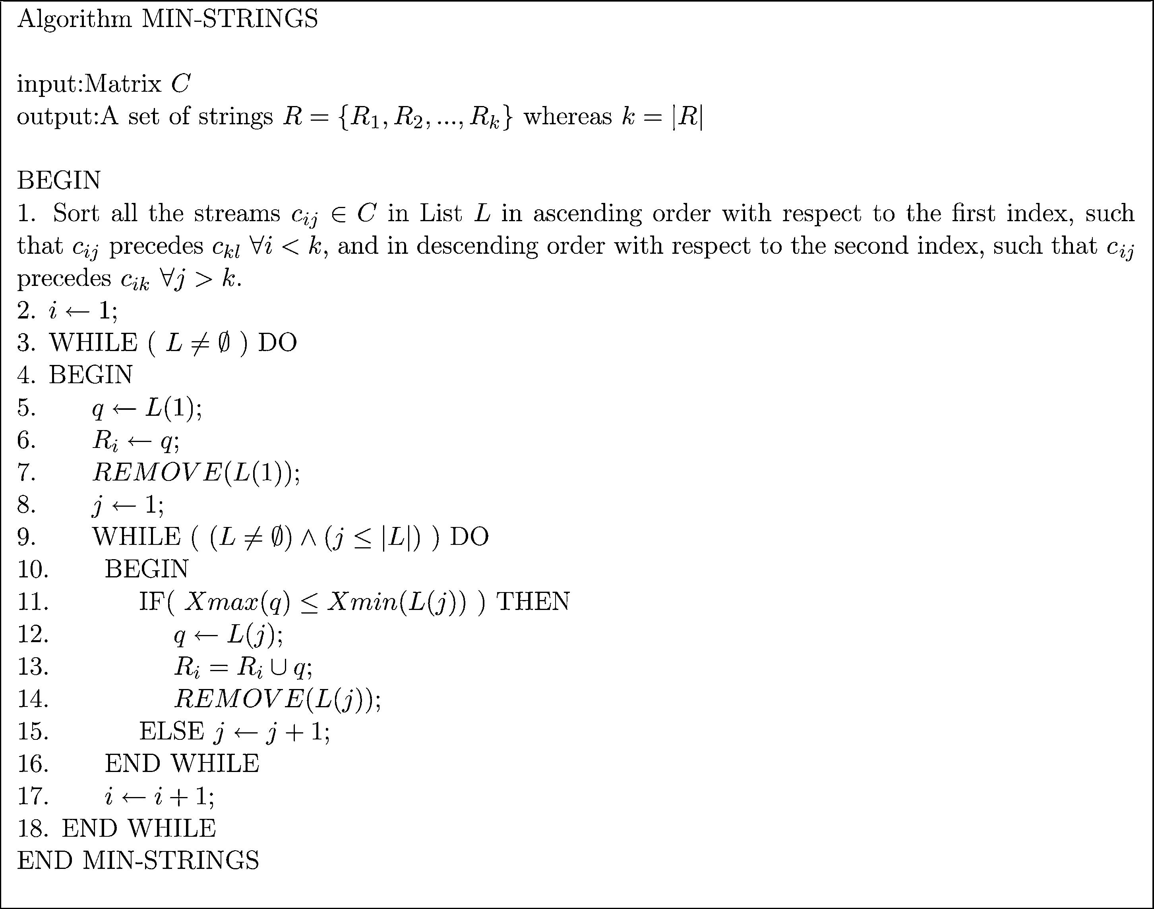
R. Ul-Mustafa, A.E. Kamal / Computer Communications 29 (2006) 1065–1078

1069

(or fewer) strings onto each wavelengths. During grouping,
our objective is to group strings together in a manner that
results in reducing the number of the ADMs.

3.2.1. Minimizing the number of strings
In this subsection we present a novel technique that
accommodates the general non-uniform trafﬁc and produces
the least number of strings, equal to the density d, thus
leading to the least number of wavelengths, W for a linear
topology.
To approach the problem in hand, a visualization of the
problem will be helpful. Considering Fig. 2 again we notice
that to compactly pack the trafﬁc streams we can combine
them horizontally as strings such that no two trafﬁc streams
in a string overlap. Formally, GZ(V, E), where V is the set
of nodes and E is the set of edges, is an interval graph
provided that one can assign to each an interval I_{v}such that
I_{u}hI_{v}is nonempty precisely when u, v2E. Visualizing
each stream as an interval we can then form an interval
graph consisting of all the streams such that, each stream is
represented by a vertex and there is an edge between each
pair of vertices (intervals) that overlaps.
The problem of ﬁnding the minimum number of strings is
then equivalent to ﬁnding a vertex coloring of the
corresponding interval graph with a minimal number of
colors [15]. The graph coloring problem for general graphs
is NP-Complete [16]. However, for interval graphs we will
present a polynomial time algorithm that is optimal in the
number of colors (in our case each color corresponds to a
string). For further information on interval graphs, coloring

of interval graphs, and its complexity issues, please consult
[15–17].
Let us represent each stream c_{kl}with a pair of coordinates
(Xmin(c_{kl}), Xmax(c_{kl})) such that Xmin(c_{kl})Zk and
Xmax(c_{kl})Zl. An ith string, R_{i}, can then be deﬁned as a
set of non-overlapping streams such that its member streams
are not present in R_{j}, where 1%j%jCj, jsi, and jCj is the
total number of streams. From now on, we will use the terms
stream and segment interchangeably.
Let L represent a sorted list of all the streams c_{ij}2C, and
L(i) represent the ith element in the list L. The sorting
criterion is explained in the algorithm itself. Also let us
deﬁne an operation REMOVE(L(i)) on list L that removes
L(i) from the list L and hence decrements its size, jLj, by one
(for iR0). The algorithm MIN-STRINGS is then given in
Fig. 4.
The algorithm MIN-STRINGS starts by sorting the
segments in list L in ascending order with respect to their
Xmin coordinate. For segments having the same Xmin
coordinates, longer segments are selected ﬁrst (for segments
with the same Xmin and length, the tie can be broken
randomly). For each string we repeat the following (lines
3–18). We ﬁrst initialize each string by the ﬁrst element in
the sorted list and remove that element from the list (lines
5–8). We then ﬁll the string by searching the whole list, and
accommodating the very ﬁrst non-overlapping segments
(lines 9–15). This way, in a single scan of the list we will be
able to ﬁll a string with available non-overlapping segments.
The algorithm MIN-STRINGS is simple and elegant and
works for any general non-uniform trafﬁc. Also, it always

Fig. 4. Algorithm MIN-STRINGS for arrangement of trafﬁc steams onto fewest number of strings.

1070

R. Ul-Mustafa, A.E. Kamal / Computer Communications 29 (2006) 1065–1078

ﬁnds the optimal (minimum) number of strings, equal to the
density d, as proven by Theorem 1 below. Moreover,
simulation results verify that the algorithm compactly packs
the segments in each string, which means that most of the
segments are connected to each other. This reduces the
number of the ADMs since two connected segments use the
same ADM at their connecting point.
We can determine the complexity of MIN-STRINGS as
follows. For each string, MIN-STRINGS scans the whole
list. As the number of the strings produced by MIN-
STRINGS is equal to the density d, the complexity of the
algorithm is O(d!^{j}Cj). If the trafﬁc between different node
pairs is uniformly distributed between zero and some
number h, then on average the total number of segments
between all nodes pairs is (N²!(h/2)), and the complexity
of the MIN-STRINGS can be given as O(d!N²!h).
Before proving the optimality of the MIN-STRING
algorithm, we will deﬁne a few terms, followed by lemmas
that are required for the proof.
Let nodes be numbered 1,2,.,N, and the links be
numbered 1,2,.,NK1, such that link i is between nodes i
and iC1. Let U be the set of all given segments, i.e. UZ{a₁,
a₂,.,a_{j}Cj}. Let j_{j}be a set that consists of segment a_{j}and all
segments that overlap with a_{j}and starts earlier than or at the
same node as a_{j}, i.e. j_{j}Z fxjxj 2Uo рXminрxЮЮ%Xminрa_{j}ЮЮ

oрXmaxрxЮO Xminрa_{j}ЮЮg. Let p_{i}be a set deﬁned as,
p_{i}Z fj_{m}jsup_{X}min^{р}a_{m}Ю%i!X_{max}рa_{m}Юmg. Basically, if a segment a_{m}
starts at node i, then p_{i}Zj_{m}. If no segment starts at node i
then we will select such a segment a_{m}, which passes through
node (link) i, and its starting point is closest to node i among
all the segments passing through node (link) i. p_{i}will then
consist of segment a_{m}and all the segments that overlap with
a_{m}. Note that if no segment passes through link i, then p_{i}will
be empty. Finally, let P be a sequence of sets p_{i}, i.e. PZ(p₁,
p₂,.,p_{N}K¹).
The following lemmas are needed for the proof of the
theorem.
See Lemma 1 in Appendix
See Corollary in Appendix.
See Lemma 2 in Appendix.
The following theorem is the main result.
See Theorem 1 in Appendix.
Fig. 5 shows the output of MIN-STRINGS for a sample
input. The trafﬁc demands are shown in Fig. 5(a). Each
segment corresponds to a single trafﬁc unit. Fig. 5(b) shows
the demands after sorting. Notice that longer segments
precede shorter segments when their Xmin coordinates are
same. Fig. 5(c) shows the output of MIN-STRINGS. Notice
that the number of strings is exactly equal to the density,
which is 8 in this case.

(a)

1
2

d = 4

1

3
4

5
6

d = 7

2

7₈
9

10

d = 7

3

d = 8

4

d = 6

5

(b)

4
3

1
2
Traffic demands

9
6₇

8
11₁₂
13
14

(c)

4
3
1
2
5

Traffic demands after sorting

9
6
7
8
5

Strings obtained by MIN-STRINGS
11
12₁₀

11

12
10

13
14

13
14

Fig. 5. Output of the MIN-STRINGS algorithm for a sample set of trafﬁc demands.

R. Ul-Mustafa, A.E. Kamal / Computer Communications 29 (2006) 1065–1078

1071

Please note that on a unidirectional ring, the segments
between original nodes and the added dummy nodes could
be overlapping. Any segment crossing the link between
nodes i and i_{C}1, for 1%i%N, overlaps with any segment
crossing the link between nodes N_{C}i and N_{C}i_{C}1. For
example, from Fig. 3(b) it appears that segments A and C
can be combined in a string. However, they are overlapping
segments. The links between nodes 6 and 8 are the same as
the links between nodes 1 and 3. Therefore, we need to
modify a few expressions for unidirectional ring. Let d_{i},iC1
be the density of the link between nodes i and iC1. For a
unidirectional ring, d_{i},iC1 can be deﬁned as:

Xi X^{N}XN X^{K}1

complexity of the technique by an order of N. In Section 5, we
will examine the trade-off between number of ADMs and the
corresponding time complexity of the heuristic, for the
unidirectional ring.

3.2.2. Grouping algorithm
By now we have the set of strings, R, of size jRj. In this
subsection we will combine the jRj strings to obtain W
wavelengths, as given by equation [4]. Also while
combining the strings, our objective will be to minimize D.
Before presenting the algorithm for grouping we deﬁne a
few terms. Let us deﬁne S_{R}i as the set of node points for
which string i needs an ADM. In general each segment

d_{i};iC¹Z
kZ1 lZiC1
n_{kl}C
kZiC2 lZiC1
n_{kl}
(7)
needs an ADM at its Xmin and Xmax positions. However,
two connected segments on the same string can share a
single ADM, because Xmax of one of the segments is the

The ﬁrst term includes all the sources before and
including node i, and the destinations after and including
node iC1. The second term considers all the sources k
between iC2 and N that are transmitting the trafﬁc either to
node iC1, or to nodes after iC1 but before node k.
Similarly, we need to make few minor modiﬁcations in
the algorithm MIN-STRINGS. While packing each string
we need to select only non-overlapping segments. There-
fore, besides checking the condition, Xmax(A)%Xmin(B)
(line 11 in MIN-STRINGS), we also need to check Xmin(A)
RXmax⁰(B), where Xmax⁰(B) is deﬁned as:
(
same as Xmin of the other segment. Please also note that in
the mapped linear topology having any Xmin or Xmax at
node i (1%i%N) is equivalent to having it on node N_{C}i,
and vice versa. We also deﬁne a saving function between
strings i and j as:
SavingрR_{i}; R_{j}Ю Z jS_{R}i^{h}S_{R}j^{j}(8)
So the saving of two strings depends on the number of
node points, where both strings need an ADM due to the
overlap of their component segments’ endpoints (Xmin
and/or Xmax). Maximizing the saving function increases the
sharing of ADMs, resulting in fewer ADMs. Also we deﬁne

Xmax⁰рBЮ_{Z}
0;
1 %X maxрBЮ%N
an operation MERGE on any two strings R_{i}and R_{j}as follows:

X maxрBЮmod N; X maxрBЮON
MERGEрR_{i}; R_{j}Ю h S_{R}) S_{R}g S_{R}
(9)

i
i
j

Note that enforcing the above constraint will take into
account the actual physical capacity of a node. Basically,
here we are making sure that each string consists of only non-
overlapping segments. Later, in a grouping algorithm we will
combine at most ‘g’ number of such strings per wavelength,
thus never exceeding the physical capacity of a node.
The number of strings determined by MIN-STRINGS in
this case, will not necessarily be equal to the density. In fact,
the problem of ﬁnding minimum number of strings in rings
can be reduced to a circular-arc coloring problem [11], which
is an NP-Complete problem [16]. The experimental results,
however, show that the number of strings determined by
MIN-STRINGS even in this case is quite close to the density.
Note that we are opening up the ring at a particular node only.
Opening the ring at different locations can affect the results of
MIN-STRINGS. The distribution of the trafﬁc between
actual node and its dummy node could also affect the total
number of strings determined by MIN-STRINGS. For
example, in Fig. 3, out of a total of h streams, say, between
nodes 2 and 4, a fraction of trafﬁc streams can be allocated
between nodes 7 and 9, thus inﬂuencing the output of MIN-
STRINGS. One of the possibility is to open the ring at each
node, each time extending the ring as explained above, and
selecting the best solution. However, this will increase the
Thus, the MERGE operation basically superimposes
those node points of a string onto another where an ADM
is needed. Let the list L now include all the elements of the set
of strings R in the order of their creation by MIN-STRINGS.
The grouping algorithm given in Fig. 6 is then executed.
The algorithm GROUPING starts with a list consisting of
all the elements of the set R. Each wavelength is initialized
with the very ﬁrst string in the list L (line 6). The added
string is removed from L (line 8). Next, such a string is
selected from all the remaining strings that has maximum
common node points, thus maximizing the saving (line 11).
The largest value of saving, corresponding to a pair of
strings, indicates that grouping these strings together in a
wavelength will lead to sharing the largest number of
ADMs. The selected string is then merged with the
previously selected strings on the same wavelength
(line 13). For each wavelength we group g strings. However,
note that the number of strings selected for the Wth
wavelength may be fewer than g. The number of ADMs
required for each wavelength is then the number of Xmin
and Xmax points over all the segments in the wavelength,
while excluding the multiplicity of common node points.
Note that we are allowing trafﬁc between same pair of nodes
to be allocated to different wavelengths.

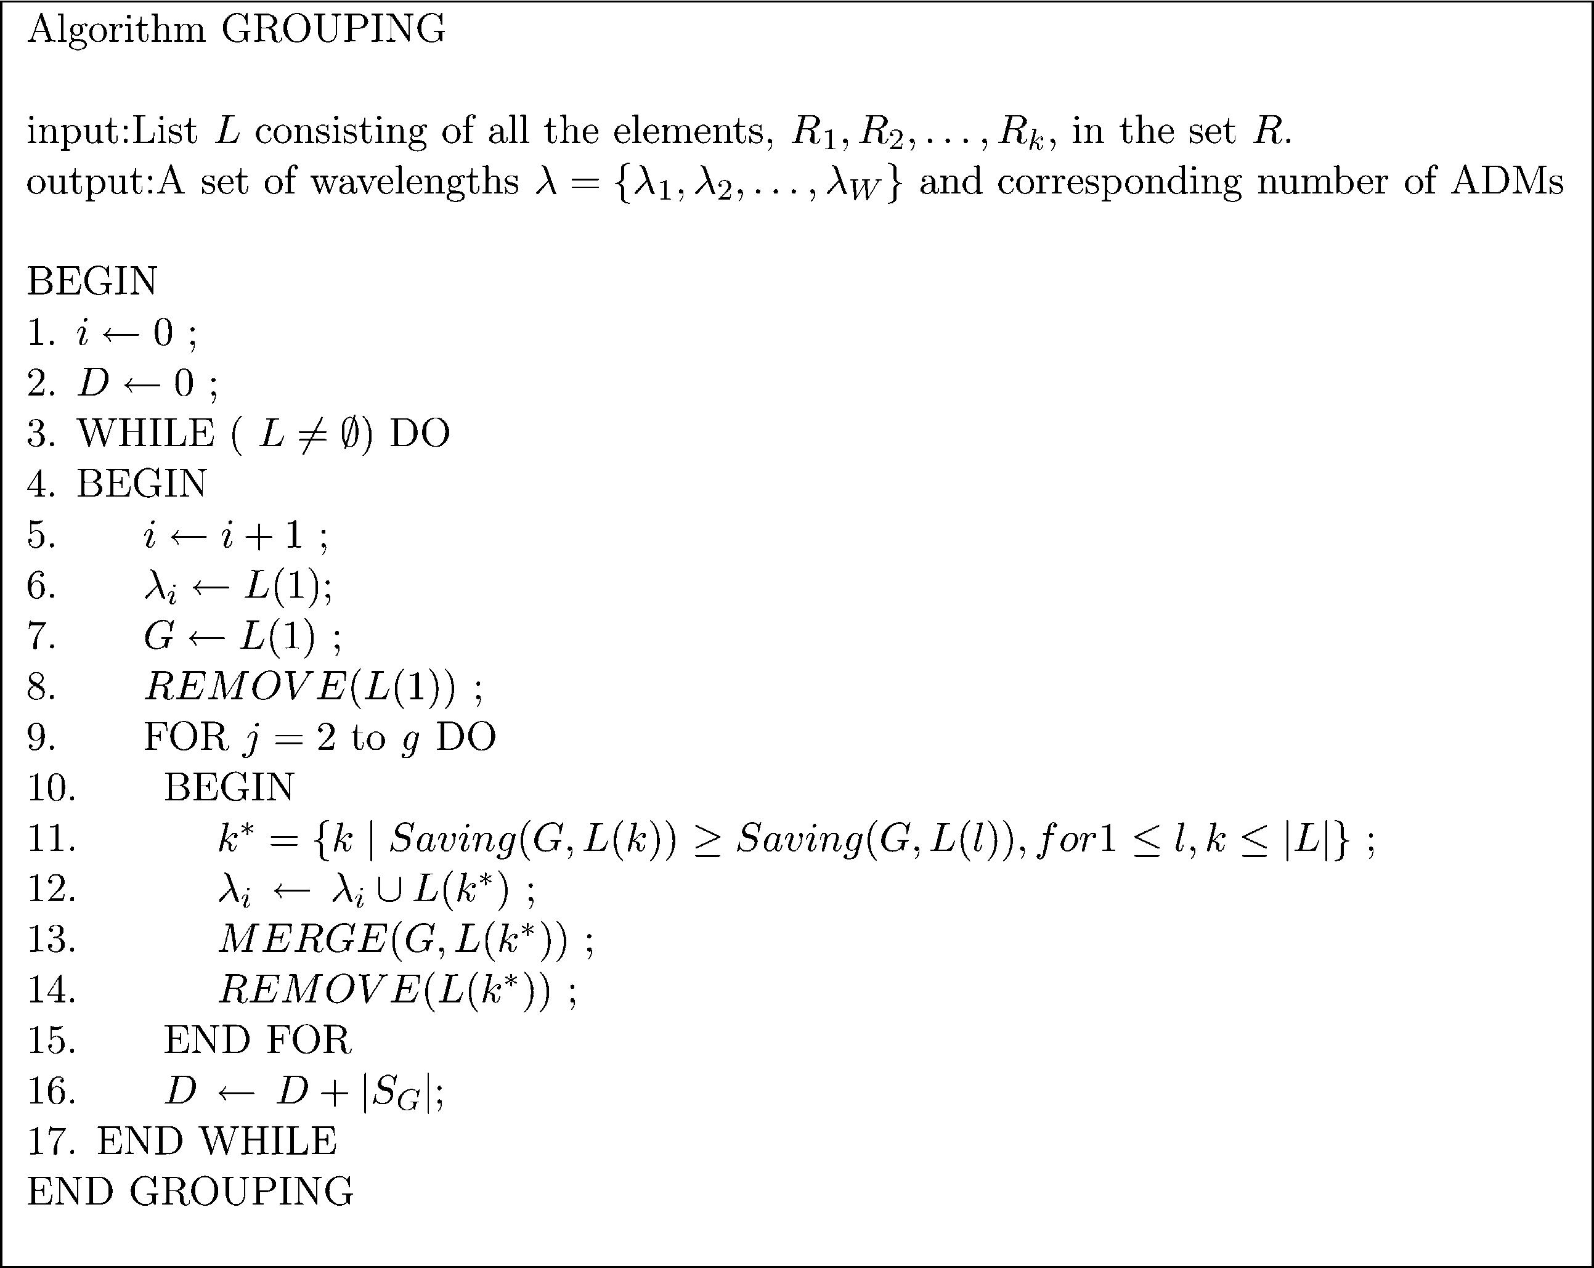
1072

R. Ul-Mustafa, A.E. Kamal / Computer Communications 29 (2006) 1065–1078

Fig. 6. Algorithm to group the strings obtained by MIN-STRINGS into W wavelengths while minimizing the number of the required ADMs.

The complexity of the algorithm GROUPING is O(jRj²).
For the linear topology, jRj_{Z}d, and hence the complexity
for linear topology can be expressed as O(d²). As jRj is
upper bounded by the total number of segments N!(h/2)
(an extreme case when each string has just one segment),
hence the dominant factor in the overall complexity of the
two-step approach comes from MIN-STRINGS that is
O(d!N²!h).

4. Trafﬁc grooming on bidirectional rings

In this section, we show how to groom the non-uniform
trafﬁc on a bidirectional ring by mapping it onto
unidirectional rings, which in turn will be mapped onto
the linear topology. Also, we explore two segment routing
options, namely, when the segments are routed using the
shortest path, and when the route is not ﬁxed and thus may
or may not follow the shortest path route.
We ﬁrst start with the shortest path approach. First, note
that similar to the case of the unidirectional ring, the linear
topology can also emulate a bidirectional ring by adding
some dummy nodes. However, this time the number of
added dummy nodes is just^{N}2 . The allocation of the trafﬁc
streams, between source s and destination d, to the extended
linear topology then can be explained as follows. When (dO
s), we will schedule the trafﬁc from s to d if (dKs!(N/2))
and from sC(N/2) to d if (dKsO(N/2)). In case when ((dK
s)!(N/2))), we will split the trafﬁc into two halves, and
assign each half from s to d and from s_{C}(N/2) to d. Also in
case when (d!s) and ((d_{K}s)O(N/2))) we will route the
trafﬁc from s to d_{C}(N/2). Note, however, that above
assignment on a single ring can lead to segments in both
directions. Applying MIN-STRINGS may result in com-
bining opposite direction segments into a string, thus
implying that a bidirectional ADM (on a single wavelength)
exists. To avoid such an assumptions and to consider ADMs
that operate only in one direction, we need to modify our
model. One of necessary update is to consider that each
wavelength can contain streams ﬂowing in one direction
only. Groups of such g wavelengths then can be assigned to
two different ﬁbers (in case of unidirectional ﬁber) or to
same ﬁber (in case of bidirectional ﬁber). Let the total trafﬁc
on a bidirectional ring be split between two unidirectional
rings A and B. Also, let the corresponding extended linear
topology, of ring A and B be represented as L(A) and L(B),
respectively. The assignment of trafﬁc to L(A) and L(B) can
then be carried out as explained in algorithm ASSIGN-
MENT, given in Fig. 7.
Algorithm ASSIGNMENT is self-explanatory. Fig. 8
shows how the trafﬁc can be split between two different
rings. Also it depicts the assignment of the trafﬁc on
corresponding extended linear topologies. The generality of
the above mentioned assignment strategy is evident by
noting that we are able to handle both symmetric and
asymmetric trafﬁc, and are still able to use the same
heuristics that we developed for the extended linear
topology for unidirectional ring.

4.1. Non-shortest path routing

In this section, we will explore non-shortest path routing
to reduce the number of the wavelengths and the ADMs.
The above mentioned assignment algorithm uses the

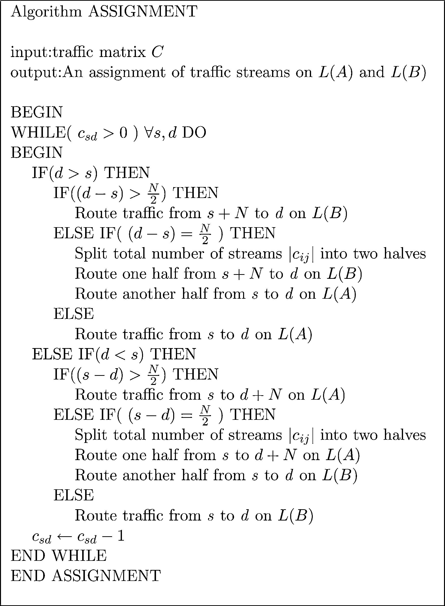
R. Ul-Mustafa, A.E. Kamal / Computer Communications 29 (2006) 1065–1078

1073

Fig. 7. Algorithm for assignment of segments on two unidirectional rings to
emulate a bidirectional ring.

shortest path to route the trafﬁc between different source
destination pairs. However, shortest path may not always
lead to the least number of the wavelengths and the ADMs.
This can be best illustrated with the help of an example.

In Fig. 9, two ring A and B are shown. Suppose g in this case
is 3. Density d of ring A currently is 2 while that of ring B is
3. Currently the number of ADMs required on each ring is
also 3. Suppose we need to route a trafﬁc stream originating
from node 2 and terminating at node 1. Using shortest path
routing we will end up selecting ring B. However, this will
not only increment the number of required wavelengths for
ring B but also needs two more ADMs. On the other hand, if
we choose the longer route on ring A, the already present
ADMs will be sufﬁcient to accommodate the stream. This
example clearly illustrates that there could arise situations
where using shortest path routing does not lead to the
minimum number of the wavelengths and the ADMs.
Hence, to address this issue in the following we will develop
an algorithm, TRAFFIC-SHIFTING, that uses three
different criteria to relax the shortest path routing restriction,
and is given in Fig. 10.
In general, we will ﬁrst assign all the trafﬁc streams on
L(A) and L(B) using shortest path. After that we will
repeatedly select the ring with larger density and check each
of the non-locked segments passing through its maximum
density link, selecting the longest segment ﬁrst. The selected
segment is then checked for its eligibility to move to the
other ring using CRITERION 1, 2 or 3. In case the shifting
of segment is approved, the segment is shifted (now being
routed over longer path) and is locked to prohibit any further
shifting (to avoid cycles). Note that, to be able to predict
exactly that a shifting of the segment from L(P) to L(Q) will
lead to the reduced number of the ADMs, we need to
determine the corresponding wavelengths of all other
segments. Due to our two step approach, however, we do
not determine the corresponding wavelengths before routing

(a)

4

5

3

1

2

(b)

4

5

3

1

2

(c)

4

5

3

1

2

(d)

1'

2'

(e)
L(A)

L(B)
1

1
2

2
3

3
4

4
5

5
6

1'
6
7

2'
7

Fig. 8. Conversion of a bidirectional ring into linear topology. bN/2c nodes are added as dummy nodes. In (a) a sample trafﬁc set is shown, while (b) and (c)
shows how trafﬁc in (a) can be split between between two unidirectional rings. Mapping of rings in (b) and (c) is shown in (d) and (e), respectively.

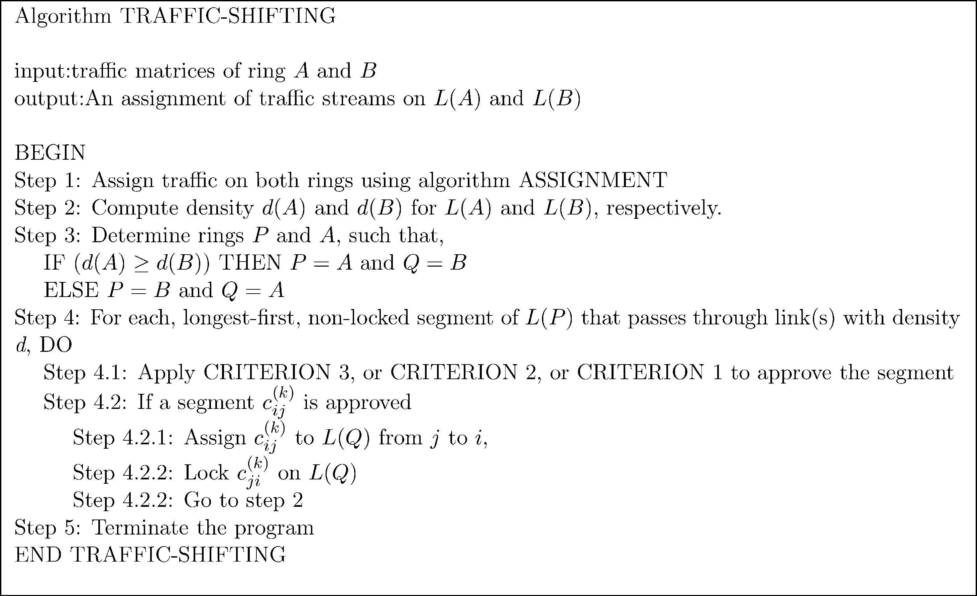
1074

R. Ul-Mustafa, A.E. Kamal / Computer Communications 29 (2006) 1065–1078

CRITERION 3, shifts the segment from one ring to another
only if such a move does not increase the density of either of

4
3

1

(a)

2

4
3

1

(b)

2
the two rings. And hence potentially decreasing the number
of strings from both the rings, P and Q, but not at the
expense of ring P. Note that using CRITERION 3 fewer
segments will be allowed to shift as compared to
CRITERION 2 and CRITERION 1. Similarly CRITERION
2 is more restrictive than CRITERION 1.

Fig. 9. Example to illustrate that the shortest path routing does not
necessarily gives the minimum number of the wavelengths and ADMs.

all of the segments. Hence, at this stage our approach tries to
reduces the total number of strings on each ring in a manner
that will not lead to an increment in the number of ADMs.
The three criteria used in algorithm TRAFFIC-SHIFTING
are explained below.
CRITERION 1 Approve the segment if d(Q) is not an
integral multiple of g, else try CRI-
TERION 2.
CRITERION 2 Approve the segment if d(P)Od(Q), else
try CRITERION 3.
CRITERION 3 Approve the segment if shifting the
segment from L(P) to L(Q) does not
increase d(Q).
The intuition behind CRITERION 1 is that if d(Q) is not
an integral multiple of g then some space will be left in at
least one of the wavelengths of ring Q, and hence we can
utilize it by placing a segment in it, while potentially
decreasing the number of strings from the ring P.
CRITERION 2 tries to balance the difference of densities
(and hence number of strings) between both rings. Finally
5. Experimental results

In this section, we will present the results of applying the
techniques proposed in Sections 3 and 4 to various networks
with different topologies and parameters. We are more
interested in conducting experiments with non-uniform and
asymmetric trafﬁc, because uniform trafﬁc can be con-
sidered as a special case of general arbitrary trafﬁc.
We divided the experiments into three suites, corre-
sponding to unidirectional topologies, bidirectional topolo-
gies, and the comparison with other similar work reported in
the literature, respectively. The following parameters were
used for the experiments in suite 1 and 2. The number of
nodes N were varied from 5 to 25 with an increment of 5.
The value of the grooming factor, g, was assigned to 1, 4, 8,
and 16 in each of these experiments. Assuming that our
basic data stream is an OC-3, these values of g then
correspond to OC-3, OC-12, OC-24, and OC-48,
respectively.
For each of the network topologies, between different
node pairs (i, j), we generated a set of trafﬁc streams c_{ij}
whose cardinality is taken from an integer uniform
distribution in the closed interval [0, g]. Each reported
result is an average value obtained by running 30 batches of

Fig. 10. Algorithm for trafﬁc shifting from shortest path to longer path, to reduce the number of required ADMs.

700
650
600
550
500
450
400
350
300
250
200
150
100
50
0

g=1

R. Ul-Mustafa, A.E. Kamal / Computer Communications 29 (2006) 1065–1078

g=4 g=8 g=16 g=1 g=4
20

15

10

5

g=8

g=16

1075

5
10
15 20 25
No. of Nodes
0
5
10
15
No. of Nodes
20
25

Fig. 11. Number of the ADMs for a unidirectional ring.

30 runs each. The conﬁdence intervals were computed, but
are not shown here.
Experiments in suite 1 were conducted on unidirectional
rings. Fig. 11 shows the number of the ADMs required for a
unidirectional ring, for different values of g. Note that when
gZ1, there will be no trafﬁc grooming, because each basic
stream will occupy the whole wavelength between source
and destination nodes. Fig. 12 compares the number of the
wavelengths determined by MIN-STRINGS for a uni-
directional ring, and the corresponding lower bound on the
number of the wavelengths, i.e. density, when gZ8. From
Fig. 12, it is evident that the number of the wavelengths
determined by MIN-STRINGS is exactly equal to lower
bound when the problem size is small (for example, when
number of nodes are 5 and 10), and slightly exceeds the
lower bound when the problem size increases. In Section 3,
we discussed the time-cost tradeoff in opening the ring at
single or multiple nodes. Fig. 13 shows the savings in the
number of the ADMs that can be obtained by opening the
unidirectional ring at each of the N nodes and selecting
the best solution. The saving in the number of the ADMs
increases when the problem size increases (and so does the
computing time). On average we are able to save 5–10
ADMs by opening it at each of the N nodes and selecting the
best solution. Given that a single port SONET ADM costs

Calculated Density
180
160
140
120
100
80
60
40
20
0

Fig. 13. Number of the ADMs saved by opening the unidirectional ring at
each of the N nodes.

$40,000 or more, this saving could mean a total saving of
$200,000–$400,000. On the other hand by opening the ring
at each of the N nodes, the time complexity increases by a
factor of N. However, the run time of our technique allows
one to afford this additional computation to save large
amounts of money while designing WDM networks. For
example, the real time taken by the program, for NZ20 and
gZ8, was 0.62 and 5.2 s when it was opened at node zero
and when it was opened at each of N nodes, respectively.
Similarly, the real time taken by the program for the above
mentioned two options was 2.71 and 21.7 s when gZ16.
Comparison of our results with other proposed techniques,
e.g. [12] reveals that with far less complexity (at least an
order of N) we have achieved either less or comparable costs
in terms of the number of the ADMs.
For all of the above experiments the amount of the trafﬁc
generated between each node pair is related to the grooming
factor (the trafﬁc generated for each node pair is an integer
uniformly distributed in the closed interval [0, g]). We also
conducted experiments to study the effect of the different
grooming factors while using the same input trafﬁc
matrices. For these experiments, the trafﬁc generated for
each node pair is an integer uniformly distributed in the
closed interval [0,16]. The results are collected for gZ4 and
gZ8. Figs. 14 and 15 show the number of the ADMs and
the number of the wavelengths required to accommodate the
input trafﬁc, respectively. Note that the number of the
wavelengths required for gZ8 are almost exactly half of
that required for gZ4, while the number of the ADMs
required for gZ8 are close to half of that required for gZ4.
This shows that our two-step approach is scalable with the
grooming factor.
In the case of rings even the ﬁrst step of our two-step
technique, i.e. minimizing the number of strings, is
NP-Complete. Therefore, to compare the performance of

5
10
15
No. of Nodes
20
25
MIN-STRINGS, in this case, we compared the results MIN-
STRINGS with the results given in [11]. In Ref. [11], the

Fig. 12. Number of the wavelengths and the corresponding lower bound for
a unidirectional ring.
authors solved the wavelength assignment problem in WDM
rings while minimizing the number of ADMs. They proposed

No. of ADMs
No. of Wavelengths
No. of ADMs

1076

R. Ul-Mustafa, A.E. Kamal / Computer Communications 29 (2006) 1065–1078

Table 1

1800
1700
1600
1500
1400
1300
1200
g=4
g=8
Average ADM saving for unidirectional rings by MIN-STRINGS versus
MAF, IMat, and IMer
Min-strings MAF IMat IMer
Avg ADM saving 76 25 31 35

1100
1000
900
800
700
600
500
Improvement1
Improvement2
–
8%
204%
224%
145%
161%
117%
131%

400
300
200
100
0

5

10

15
No. of Nodes

20

25
ﬁgure, it is evident that we can improve on the shortest path
approach by relaxing the shortest path constraint. Also both
C1 and C2 perform better than C3, because they have more
ﬂexibility in shifting the trafﬁc streams from shortest path
routes to other routes. Table 2 shows the saving in the

Fig. 14. Number of the ADMs when the same input matrices are used for the
experiments with gZ4 and 8.

three heuristics, namely, Modiﬁed Assign First (MAF),
Iterative Matching (IMat) and Iterative Merging (IMer), and
presented the ADM savings over 200 experiments. Whenever
two segments shared a common node this was counted as an
ADM saving. Table 1, compares the performance of MIN-
STRINGS to the MAF, IMat, and IMer heuristics, for the
same network setup (NZ16, and number of streams
generated randomly between 16 and 256). On average, our
proposed MIN-STRINGS algorithm performed 204, 145,
and 117% better than MAF, IMat, and IMer, respectively,
which is shown by Improvement1 in Table 1. We also
experimented by opening the ring at each of the N nodes, and
selecting the best solution. This introduced an improvement
over our initial solution which is about 8% (shown in Table 1
as Improvement2). This translates into a further improve-
ment of 20, 16, and 14%, over MAF, IMat, and IMer,
respectively.
Suite 2 consists of experiments for bidirectional rings.
Fig. 16 shows the number of the ADMs required for a
bidirectional ring, using shortest path and TRAFFIC-
SHIFTING algorithm, when gZ16. Note that the results
were collected for the TRAFFIC-SHIFTING algorithm with
all three different criteria, namely, CRITERION 1 (C1),
CRITERION 2 (C2), and CRITERION 3 (C3). From the

g=4 g=8
number of ADMs obtained by using C1, C2, and C3 over the
shortest path routing (C0) option, when gZ8. Using either
C1 or C2, for large problem sizes we were able to save 74
ADMs. On average, criteria C1, C2 and C3 saved 36.1, 35.6,
and 6.2 ADMs, respectively, over shortest path option.
Using $40,000 as the price for a single port SONET ADM,
this saving translates into 1.44 million, 1.42 million, and
0.24 million dollars, respectively.
Suite 3 consists of experiments conducted to compare the
similar work done by authors in Ref. [12]. We selected the
same parameters as reported in [12] to be able to make
meaningful comparisons. We will report four different
experiments. Since the authors in [12] provided many
results for uniform trafﬁc, in Fig. 17 we compared the
performance of our algorithms for gZ4 and a uniform
trafﬁc of three units between randomly selected node pairs,
on a unidirectional ring. We used both variations: opening
the ring at a single link (Single open), and opening the ring
at each of the N links and selecting the best results (N open).
However, in this case both variations yield the same results.
We attribute this to the uniform nature of the trafﬁc between
different node pairs. Fig. 17 shows the number of ADMs
saved by using our algorithms over that of reported in Ref.
[12]. Keeping in mind that each ADM costs thousand of
dollars the saving in the number of ADMs is substantial. For
second experiment we generated a non-uniform trafﬁc in the
closed interval [0,5] for a unidirectional ring. Fig. 18 shows

650
600
550
500
450
400
350
300
250
200
150
100
50
0

5

10

15
No. of Nodes

20

25

950
900
850
800
750
700
650
600
550
500
450
400
350
300
250
200
150
100
50
0

5
C0

10
C1

15
C2

20
C3

25

Fig. 15. Number of the wavelengths when the same input matrices are used
for the experiments with gZ4 and 8.
No. of Nodes

Fig. 16. No. of the ADMs for a bidirectional ring; gZ16.

No. of ADMs
No. of Wavelengths
No. of ADMs

Table 2

R. Ul-Mustafa, A.E. Kamal / Computer Communications 29 (2006) 1065–1078

80

1077

Saving in number of ADMs using TRAFFIC-SHIFTING algorithm for
bidirectional ring when gZ8

70

N
10
15
20
25
C0–C1
5.7
18.4
46.5
74
C0–C2
6
17.2
45.3
74
C0–C3
0.5
1.4
9.4
13.8

60

50

40

Zhang, g=8

the results when gZ4. We notice that the performance of
Our, g=8

our algorithms increase over that reported in [12], when
non-uniform trafﬁc is considered. Also, opening the ring at
each of the N links, though increases the complexity, saves
substantial number of ADMs while accommodating the very
same trafﬁc. The third experiment is also conducted on a
30

20
Zhang, g=16
Our, g=16
8 9 10 11 12 13 14 15 16 17 18 19 20
No. of Nodes

unidirectional ring. Non-uniform trafﬁc is generated in the
closed interval [0,5]. However, grooming factors of 8 and 16
are considered. We computed the Saving Percentage in
ADMs, as deﬁned in Ref. [12], SZ рN:W_{K}DЮ=рN:W Ю, where
as D was deﬁned earlier as the total number of SONET
Fig. 19. Saving percentage in ADMs, with non-uniform trafﬁc, gZ8 and 16,
on a unidirectional ring.

ADMs required to accommodate the trafﬁc. Fig. 19 shows
that for both gZ8 and 16 in most of the cases the saving
percentage of ADMs generated by our algorithms is more
than that reported in Ref. [12]. Finally, the fourth

16
14
12
10
8
6
4
2
0
Zhang
Our, Single open
Our, N open
experiment is conducted on a bidirectional ring. Grooming
factors of 8 and 16 are considered and a non-uniform trafﬁc
is generated in the closed interval [0,5]. Once again results,
shown in Fig. 20, illustrate that in most of the cases the
saving percentage of ADMs obtained by our algorithms is
more than that reported in Ref. [12]. Thus this suite of
experiments demonstrates that our proposed algorithms can
generate cost-effective solutions in less, or at most equal,
computation complexity.

6. Conclusions

8 9 10 11 12 13 14 15 16 17 18 19 20
No. of Nodes

Fig. 17. Number of the ADMs saved with uniform trafﬁc and gZ4 on a
unidirectional ring.

In this paper, we address the grooming of the non-uniform
trafﬁc on unidirectional and bidirectional rings. We map the
unidirectional rings onto a linear topology, and then develop
a two-step approach to solve the grooming problem, while

45
40
35
30
25
20
15
10
5
0

Zhang

Our, Single open

Our, N open

60

50

40

30

20

10

0

Zhang, g=8
Our, g=8
Zhang, g=16
Our, g=16

8 9 10 11 12 13 14 15 16 17 18 19 20
No. of Nodes

Fig. 18. Number of the ADMs saved with non-uniform trafﬁc and gZ4 on a
unidirectional ring.
8 9 10 11 12 13 14 15 16 17 18 19 20
No. of Nodes

Fig. 20. Saving percentage in ADMs, with non-uniform trafﬁc, gZ8 and 16,
on a bidirectional ring.

No. of ADMs Saved
No. of ADMs Saved
Saving Percentage in ADMs
Saving Percentage in ADMs

1078

R. Ul-Mustafa, A.E. Kamal / Computer Communications 29 (2006) 1065–1078

minimizing the number of the wavelengths and the ADMs,
for the mapped topologies. For the ﬁrst step, an algorithm
MIN-STRINGS is developed that produces the optimal
(minimum) number of strings on a linear topology, while
compacting each string with trafﬁc streams. Optimality of the
algorithm is proven. For the second step, an effective
heuristic is designed to group g strings for each wavelength
such that the number of the ADMs used per wavelength are
minimized. Also, the bidirectional rings are mapped onto
unidirectional rings and the two-step approach is used.
Moreover, a study is conducted on routing strategies for
bidirectional rings to minimize the number of the required
wavelengths and ADMs. Few approaches are proposed that
lead to considerable reduction in the number of the required
wavelengths and ADMs. Finally, the efﬁcacy of the proposed
techniques is demonstrated using a large set of experiments.

Acknowledgements

This research was supported by grant ANI-0087746 from
the National Science Foundation.

Appendix A
Lemma 1. jj_{j}j%d for 1%j%jCj
Proof. jj_{j}jOd implies that at some link, say l, where lZ
Xmin(a_{j}), the number of segments traversing the link is greater
than d, which contradicts the deﬁnition of d. Hence jj_{j}j%d.
Corollary. jp_{i}j%d for 1%i%NK1
Proof. By deﬁnition, p_{i}Zj_{m}for 1%m%jCj, or p_{i}Zf. How-
ever, from Lemma 1 we have jj_{m}j%d. Hence, jp_{i}j%d. ,
Lemma 2. In each iteration, k, of the MIN-STRINGS
algorithm (lines 3–18, Fig. 4), exactly one member of each
nonempty p_{i}, 1%i%NK1, will be selected for inclusion in
string k.
Proof. As MIN-STRINGS ﬁrst sorts all the segments in
ascending order with respect to their Xmin coordinates, in
each iteration k (lines 3–18, Fig. 4), the sequence P will be
inspected in order, and if the element, p_{i}, is not empty then:

(a) Either the segment that was chosen in the previous
nonempty element, p_{j}, is not a member of p_{i}, and
therefore does not overlap with the members in p_{i}. In this
case, a new segment in p_{i}can be chosen for inclusion in
the string, and will be removed from set p_{i}. Or,
(b) the segment, a_{k}, that was last chosen from the previous
non-empty member, p_{j}, is also a member of p_{i}, and will
also be removed from p_{i}. ,
In both cases, the size of all the nonempty sets, p_{i}, which
are members of the sequence L, will be reduced by 1.
Theorem 1. MIN-STRINGS algorithm is optimal in the
number of strings.

Proof. As d is the lower bound on the number of strings, we
will prove that the number of strings obtained by MIN-
STRINGS algorithm is equal to d, i.e. jRj_{Z}d, and is
therefore optimal. Since jp_{i}j%d, 1%i%(NK1), then by
Lemma 2, in d or less iterations we will be able to select all
the segments a_{k}2p_{i}, for the strings. Let k*be the link with
density d. Then jp_{k}*^{j}Zd. Hence the total number of
iterations required to select all the segments is d. Since each
iteration corresponds to a string, then jRjZd. ,

References

[1] R. Ramaswami, K. Sivarajan, Optical Networks: A Practical
Perspective, second ed., Morgan Kaufmann, San Mateo,CA, 2001.
[2] A.L. Chiu, E.H. Modiano, Trafﬁc grooming algorithms for reducing
electronic multiplexing costs in WDM ring networks, Journal of
Lightwave Technology 18 (1) (2000) 2–12.
[3] E. Modiano, Trafﬁc grooming in WDM networks, IEEE Communi-
cations Magazine (2001) 124–129.
[4] R. Dutta, G. Rouskas, Trafﬁc grooming in WDM networks: past and
future, IEEE Network 16 (6) (2002) 46–56.
[5] K. Zhu, B. Mukherjee, A review of trafﬁc grooming in WDM optical
networks: architecture and challenges, Optical Networks Magazine 4
(2) (2003).
[6] O. Gerstel, R. Ramaswami, G. Sasaki, Cost-effective trafﬁc grooming
in WDM rings, IEEE/ACM Transactions on Networking 8 (5) (2000)
618–630.
[7] O. Gerstel, P. Lin, G. Sasaki, Combined WDM and SONET design
Proceedings of IEEE INFOCOM’99 1999 pp. 734–43.
[8] X.-Y. Li, L.-W. Liu, P.-J. Wan, O. Frieder, Practical trafﬁc grooming
scheme for single-hub SONET/WDM rings Proceedings of IEEE 25th
Annual Conference on Local Computer Networks (LCN) 2000 pp.
556–64.
[9] R. Dutta, G.N. Rouskas, On optimal trafﬁc grooming in WDM rings,
IEEE Journal on Selected Areas in Communication 20 (1) (2002)
110–121.
[10] P.-J. Wan, G. Calinescu, L. Liu, O. Frieder, Grooming of arbitrary
trafﬁc in SONET/WDM BLSRs, IEEE Journal of Selected Areas in
Communications (2000) 1995–2003.
[11] L Liu, X. Li, P.-J. Wan, O. Frieder, Wavelength assignment in WDM
rings to minimize SONET ADMs Proceedings of IEEE INFO-
COM’2000 2000 pp. 1020–25.
[12] X. Zhang, C. Qiao, An effective and comprehensive approach for
trafﬁc grooming and wavelength assignment in SONET/WDM rings,
IEEE/ACM Transactions on Networking 8 (5) (2000) 608–617.
[13] W. Cho, J. Wang, B. Mukherjee, Improved approaches for cost-
effective trafﬁc grooming in WDM ring networks: uniform-trafﬁc
case, Photonic Network Communications 3 (3) (2001) 245–254.
[14] O. Gerstel, P. Lin, G. Sasaki, Wavelength assignment in a WDM ring
to minimize cost of embedded SONET rings Proceedings of IEEE
INFOCOM’98 1998 pp. 94–101.
[15] P.C. Fishburn, Interval Orders and Interval Graphs, John Wiley, New
York, 1985.
[16] M. Garey, D. Johnson, G. Miller, C. Papadimitriou, The complexity of
coloring circular arc graphs and chords, SIAM Journal on Algebraic
and Discrete Methods 1 (2) (1980) 216–227.
[17] U. Gupta, D. Lee, J. -T. Leung, Efﬁcient algorithms for interval graphs
and circular-arc graphs, Networks 12 (1980) 459–467.
[18] K. Zhu, B. Mukherjee, Trafﬁc grooming in a WDM mesh network,
IEEE Journal on Selected Areas in Communications 20 (1) (2002)
122–133.
[19] S. Thiagarajan, A.K. Somani, Trafﬁc grooming for survivable WDM
mesh networks Proceedings of OPTICOMM 2001.

